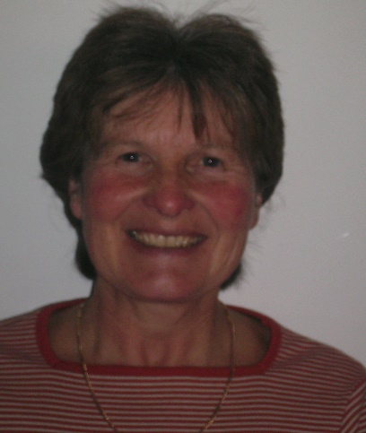
WELFARE OFFICER
ROSE BROWN

My name is Rose Brown and as a member of Lichfield Friary Tennis Club I am here to help promote a healthy, safe, exciting and challenging environment for all members and participants.
At LFTC we hope children and adults can experience a positive and welcoming atmosphere where participants can enjoy and achieve success in their tennis.
As Welfare Officer my role is to promote safeguarding.
I will listen to and respond to any concerns or issues raised by children, adults, parents, coaches and volunteers.
Contact details Phone 0780 9667359
E mail brownrh.rb@gmail.com

