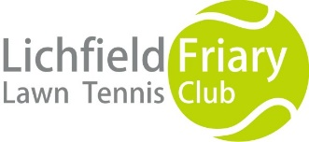
Lichfield Friary Tennis Club Clothing
Order Form

We have adult and junior polo / T shirts, hoodies and sweatshirts available to order. All items come with the club logo embroidered on front left hand side. Please see catalogue for full details including colour and size options. Catalogues are available in the club house and on our website (lichfieldfriarytennis.co.uk)
To order your items please complete the following order details
Name:-
Contact number / email:-
Order number | Item description | Size | Colour | Qty | Total (£)
 |  |  |  |  | £
 |  |  |  |  | £
 |  |  |  |  | £
 |  |  |  |  | £
 |  |  |  |  | £
 |  |  |  |  | £
 |  |  |  |  | £
 |  |  |  |  | £
 |  |  |  |  | £
 |  |  |  |  | £
 |  |  |  |  | £
 |  |  |  |  | £
 |  |  |  |  | £
Order Total |  |  |  |  | £

Payment required up front with order please
Please tick payment option used:-
Payment made by cash cheque (made payable to Lichfield Friary LTC)

Bank transfer PLEASE IDENTIFY YOUR PAYMENT WITH YOUR FULL NAME
Bank: Barclays Account name: Lichfield Friary Lawn Tennis Club,
Sort code: 20-85-13 Account no: 80579831

Please return completed order forms to Caroline Lort, Peartree Barn, Pipe Hill Farm, Lichfield, WS13 8JT
Email:- carolinelort@hotmail.co.uk
Alternatively please pin your order form and cheque in an envelope on the notice board in the club house marked FAO Caroline Lort in the club house.

